PASSWORD SECURITY AUDIT TOOL

NAME: Thamizh Selvi

INTRODUCTION:
The Password Security Audit Tool is a Python-based security tool used to analyze the strength and security of passwords. It checks password length, uppercase and lowercase characters, numbers, special characters, common passwords, estimated crack time, and generates a stronger password suggestion. It also uses bcrypt to securely hash passwords.

OBJECTIVE:
To check the strength of a given password.
To identify common and weak passwords.
To estimate the approximate password cracking time.
To generate a stronger password suggestion.
To securely hash passwords using bcrypt.
To improve awareness of password security.

TOOLS AND TECHNOLOGIES USED:
Programming Language: Python
IDE: Python IDLE
Library: bcrypt
File: common_passwords.txt
Platform: Windows

PASSWORD STRENGTH CHECKING:
The tool checks whether the password contains a sufficient number of characters and includes uppercase letters, lowercase letters, numbers, and special characters. These checks help identify whether a password follows basic password security requirements.
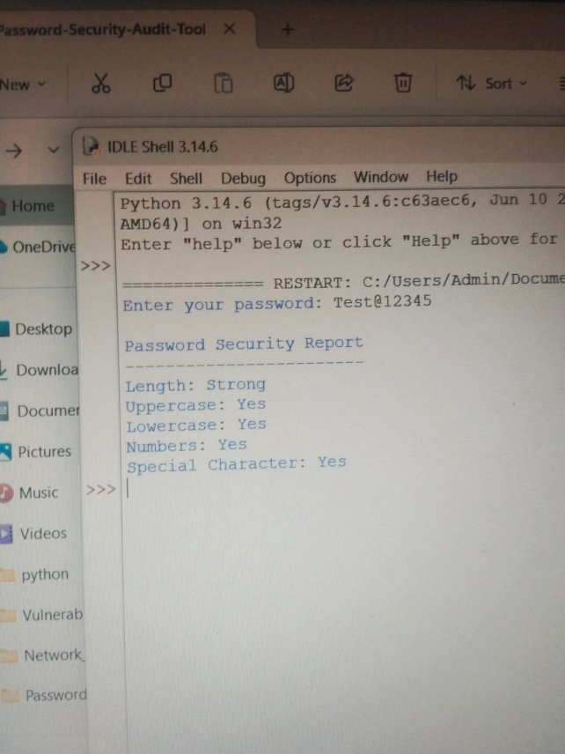

COMMON PASSWORD CHECKING:
The tool checks the entered password against a list of commonly used passwords stored in the common_passwords.txt file. If the password is found in the list, it is reported as a common and weak password.
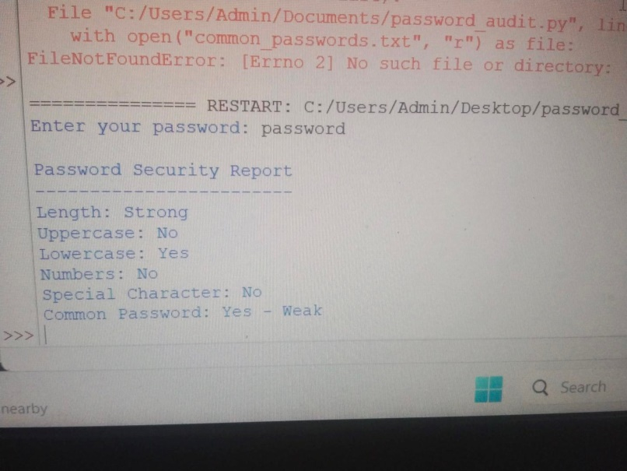

PASSWORD CRACK TIME ESTIMATION:
The tool estimates the approximate time required to crack a password using a brute-force approach. The estimation is based on the password length, available character types, and an assumed number of guesses per second. A stronger and longer password generally requires more time to crack.
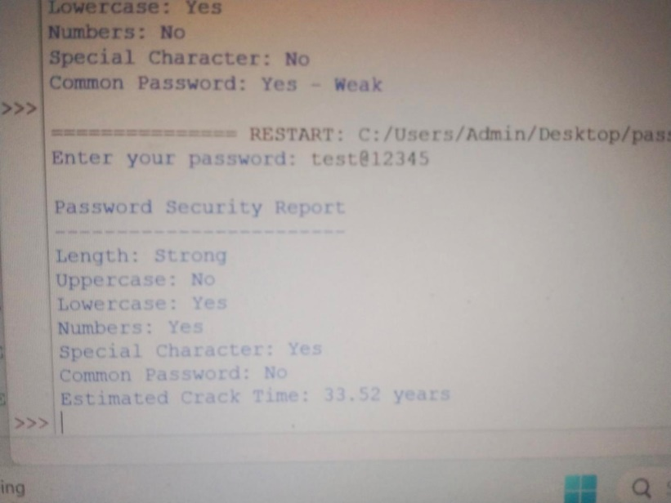

STRONG PASSWORD GENERATION:
The tool generates a random 16-character password using uppercase letters, lowercase letters, numbers, and special characters. This helps users create stronger passwords that are difficult to guess or crack.
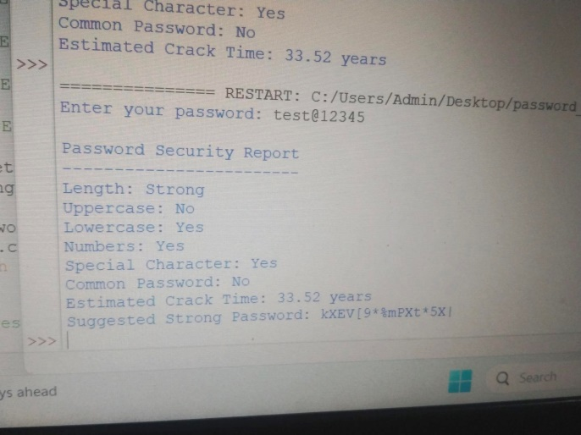

SECURE PASSWORD HASHING USING BCRYPT:
The tool uses the bcrypt hashing algorithm to securely protect passwords. Instead of storing the original password, bcrypt converts it into a salted hash. This improves password security and helps protect stored passwords from being exposed in plain text.
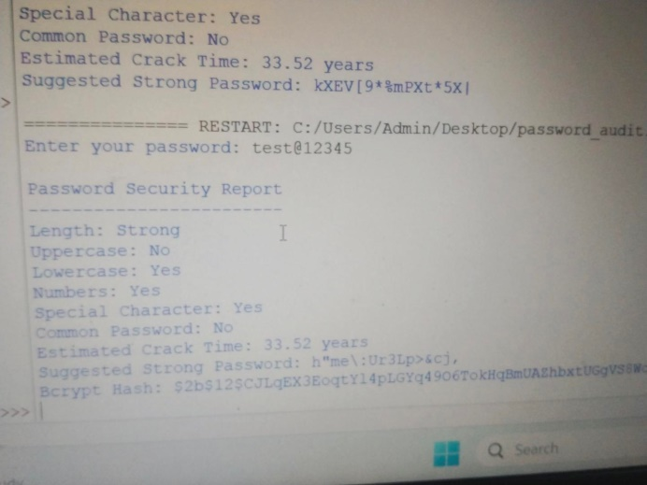

TESTING AND RESULTS:
The Password Security Audit Tool was tested with different passwords to verify its functionality. The tool successfully checked password strength, identified common passwords, estimated crack time, generated strong password suggestions, and produced bcrypt hashes. The test results show that the tool performs the required password security checks successfully.

CONCLUSION:
The Password Security Audit Tool provides a simple and effective way to understand password security. It can identify weak and common passwords, estimate crack time, generate strong passwords, and securely hash passwords using bcrypt. This project helped in understanding the importance of strong passwords and secure password storage.

